Who is your competitor?

You are a new marketing analysis at Hannah Solar, a manufacturer that produces solar panels to the retail market. This morning, you received a memo indicating that Efacec USA, a competing manufacturer, may substantially lower the price of their products. Your company is concerned about the negative impact this might have on its market share.

Andrew, one of your colleagues, thinks that Petra Solar is Hannah Solar’s main competitor and that Efacec’s new campaign will NOT substantially influence Hannah Solar’s market share. This is because, Andrew argues, Efacec’s solar panels are crystalline silicon-based, while both Hannah and Petra’s products are made with thin film technology, which is cheaper but has lower level of energy efficiency. Furthermore, Efacec has two different products, type I and type II, while both Petra and your company, Hannah, has only one major product.

It is very hard to argue with Andrew, who has been working in the company longer than you. Andrew is a good looking guy an also a smooth talker. People in your company tend to follow his opinion. However, one important lesson that you learnt in MGMT 670 is that smooth talking cannot stand ground unless it is supported by data. So you decided to investigate Andrew’s claim more carefully.

Some data are available to you (see the competitor file). The data were compiled at a weekly level and consist of information on Hannah’s market share along with its price, as well as Petra’s prices and Efacec’s prices (1 and 2). Prices are given in tens of dollars (i.e., 135 = $1,350) and market share is given in decimal form (i.e., 0.04 = 4%). There are 113 weeks of data.

week | marketshare | Hannah | Petra | Efacec1 | Efacec2
1 | 0.045456499 | 149 | 169 | 169 | 179
2 | 0.093014501 | 149 | 199 | 189 | 199
3 | 0.059665602 | 189 | 199 | 189 | 199
4 | 0.0345966 | 189 | 199 | 189 | 199
5 | 0.027653599 | 189 | 169 | 159 | 169
6 | 0.029422401 | 189 | 199 | 189 | 199
7 | 0.036883201 | 189 | 199 | 189 | 199
…. | … | … | … | … | …
112 | 0.061790898 | 159 | 169 | 179 | 189
113 | 0.074795298 | 149 | 169 | 179 | 189

 | marketshare | Hannah | Petra | Efacec1 | Efacec2
1 | 0.045456 | 149 | 169 | 169 | 179
2 | 0.093015 | 149 | 199 | 189 | 199
3 | 0.059666 | 189 | 199 | 189 | 199
4 | 0.034597 | 189 | 199 | 189 | 199
5 | 0.027654 | 189 | 169 | 159 | 169
6 | 0.029422 | 189 | 199 | 189 | 199
7 | 0.036883 | 189 | 199 | 189 | 199
8 | 0.041337 | 189 | 189 | 189 | 199
9 | 0.02913 | 189 | 189 | 169 | 179
10 | 0.039164 | 189 | 189 | 189 | 199
11 | 0.033574 | 189 | 189 | 189 | 199
12 | 0.034527 | 189 | 179 | 189 | 199
13 | 0.041544 | 189 | 189 | 189 | 199
14 | 0.035472 | 189 | 189 | 189 | 199
15 | 0.037291 | 189 | 179 | 189 | 199
16 | 0.038774 | 189 | 189 | 189 | 199
17 | 0.034631 | 179 | 189 | 179 | 189

You run a couple of regressions on this data, which is given below. You now try to remember statistics to understand these regressions in order to argue for or against Andrew.

Here is a regression that you run.
Regression Analysis: marketshare versus Hannah, Petra, Efacec1, Efacec2

Analysis of Variance

Source DF Adj SS Adj MS F-Value P-Value
Regression 4 0.012014 0.003003 30.00 0.000
Hannah 1 0.008826 0.008826 88.16 0.000
Petra 1 0.000969 0.000969 9.68 0.002
Efacec1 1 0.000110 0.000110 1.10 0.297
Efacec2 1 0.000012 0.000012 0.12 0.728
Error 108 0.010812 0.000100
Lack-of-Fit 49 0.006692 0.000137 1.96 0.007
Pure Error 59 0.004120 0.000070
Total 112 0.022826

Model Summary

S R-sq R-sq(adj) R-sq(pred)
0.0100055 52.63% 50.88% 47.57%

Coefficients

Term Coef SE Coef T-Value P-Value VIF
Constant 0.0403 0.0141 2.85 0.005
Hannah -0.000760 0.000081 -9.39 0.000 1.36
Petra 0.000262 0.000084 3.11 0.002 1.66
Efacec1 0.000347 0.000332 1.05 0.297 25.97
Efacec2 0.000102 0.000294 0.35 0.728 25.15

Regression Equation

marketshare = 0.0403 - 0.000760 Hannah + 0.000262 Petra + 0.000347 Efacec1 + 0.000102 Efacec2

- What is the regression equation? Do the signs of the coefficients for each of the price make sense?

- What are explained, unexplained variations? SST=SSR+SSE

- What is R-square, adjusted R-square? Why do we need adjusted R-square?

Now, you look at more serious statistical analysis, assuming (alpha=1%)

- Is there a significant relationship between all the predictor variables and the response?

- Next, is there a significant relationship between Hannah price and Market share?

- Is there a significant relationship between Petra price and Market share?

- Is there a significant relationship between Efacec1 price and Market share?

- Is there a significant relationship between Efacec2 price and Market share?

From the analysis above, seems like Andrew is right after all. Neither Efacec1 nor Efacec 2 are significant. Well maybe Andrew is not only a smooth talker but also a smart guy. That’s why he is so popular. But according to your experiences, such people do not exist. So you decided to do another regression. This time you drop one variable, Efacec 2. Here is the output.

Regression Analysis: marketshare versus Hannah, Petra, Efacec1

Analysis of Variance

Source DF Adj SS Adj MS F-Value P-Value
Regression 3 0.012002 0.004001 40.29 0.000
Hannah 1 0.009160 0.009160 92.24 0.000
Petra 1 0.000979 0.000979 9.86 0.002
Efacec1 1 0.003434 0.003434 34.58 0.000
Error 109 0.010824 0.000099
Lack-of-Fit 47 0.006282 0.000134 1.82 0.013
Pure Error 62 0.004542 0.000073
Total 112 0.022826

Model Summary

S R-sq R-sq(adj) R-sq(pred)
0.0099651 52.58% 51.27% 48.33%

Coefficients

Term Coef SE Coef T-Value P-Value VIF
Constant 0.0401 0.0140 2.85 0.005
Hannah -0.000764 0.000080 -9.60 0.000 1.33
Petra 0.000263 0.000084 3.14 0.002 1.66
Efacec1 0.000460 0.000078 5.88 0.000 1.45

Regression Equation

marketshare = 0.0401 - 0.000764 Hannah + 0.000263 Petra + 0.000460 Efacec1

- Using this regression is there a significant relationship between Hannah price and Market share? (alpha=1%)

- Is there a significant relationship between Petra price and Market share? (alpha=1%)

- Is there a significant relationship between Efacec1 price and Market share? (alpha=1%)


What is going on?

It turns out, understanding this is as easy as making a margarita!




Efacec1 and Efacec2 are like lemon and lime!

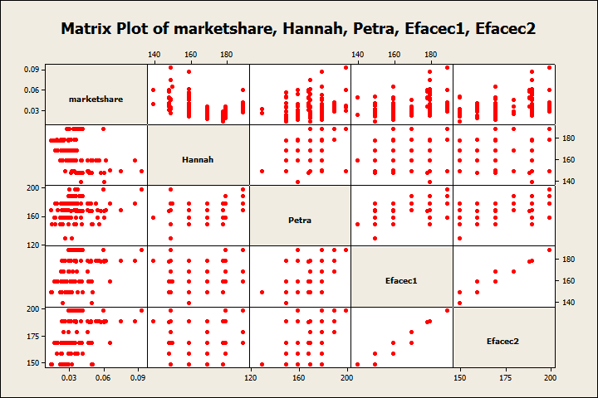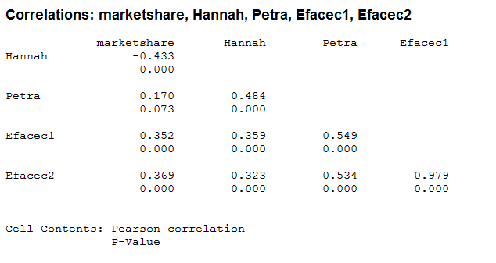

High correlation among predictor variables causes Multicollinearity Problem. This makes conclusion from regression less accurate.

So is Efacec significant? Partial F-test
Seems like it is. But to answer this precisely, we need to ask a more complex question:

Are Efacec1 and Efacec2 significant TOGETHER? In other words, we want to show that at least of one of the Efacec prices is significant. (Or we need either lemon or lime to make a Margarita)

- To test this we set up the following Hypothesis:

- What are the Full model and Reduced model?

- Partial F-test is. What is its interpretation?

- How can we decide with level of significant 5%; 1%?

WHAT VARIABLES TO CHOOSE?

To make the best regression model, we, thus, need to choose carefully the predictor variables. Just like making a margarita, we don’t want to include all ingredients.

For now, choose the one with the largest adjusted R-square.
You can do this in Minitab: regression->regression->best subsets

Best Subsets Regression: marketshare versus Hannah, Petra, ...

Response is marketshare

E E
H f f
a P a a
n e c c
n t e e
R-Sq R-Sq Mallows a r c c
Vars R-Sq (adj) (pred) Cp S h a 1 2
1 18.7 18.0 15.5 76.3 0.012926 X
1 13.7 12.9 10.6 87.9 0.013325 X
2 48.3 47.4 44.8 10.9 0.010359 X X
2 47.7 46.7 44.3 12.3 0.010420 X X
3 52.6 51.3 48.3 3.1 0.0099651 X X X
3 52.2 50.8 47.9 4.1 0.010010 X X X
4 52.6 50.9 47.6 5.0 0.010005 X X X X

- Which one has the largest adjusted R-square?

- Use this model to conclude whether Andrew is right or not.

- Now, you can also use this model to predict.
What is 95% Prediction interval of your market share if Hannah price: 150, Petra 200, Efacec1: 180, Efacec2:190

